This project is generously funded by [IES VLL](https://ies.ed.gov/funding/grantsearch/details.asp?ID=1804) ([Virtual Learning Lab](https://virtuallearninglab.org/)), [UF AI Catalyst](https://research.ufl.edu/finding-funding/internal-competitive-funding.html), and [UFII Seed Grant](https://informatics.research.ufl.edu/ufii-programs/seed-funds.html). To efficiently and effectively address students' low level of participation in online collaborative learning at a large scale, researchers have adopted learning design principles with learning analytics. A promising approach in automatically supporting students' online collaboration are conversational AI (ConvAI). ConvAI and chatbot are two terms often used interchangeably, which are defined as human- developed software powered by natural language processing techniques (NLP) to spontaneously respond to human languages. There are two distinct ways of constructing ConvAI. The first is a rule-based agent that requires manual engineering with classical NLP methods, and the other uses AI to generate responses with automatic data-driven inferences. This project aims to investigate and develop ConvAI using deep learning to support students with human-like, supportive, and safe texts automatically. Specifically, we have examined giant deep learning models with hundreds of millions and even billions of parameters to provide conversational support to students.

Conceptual framework to construct safe and supportive ConvAI

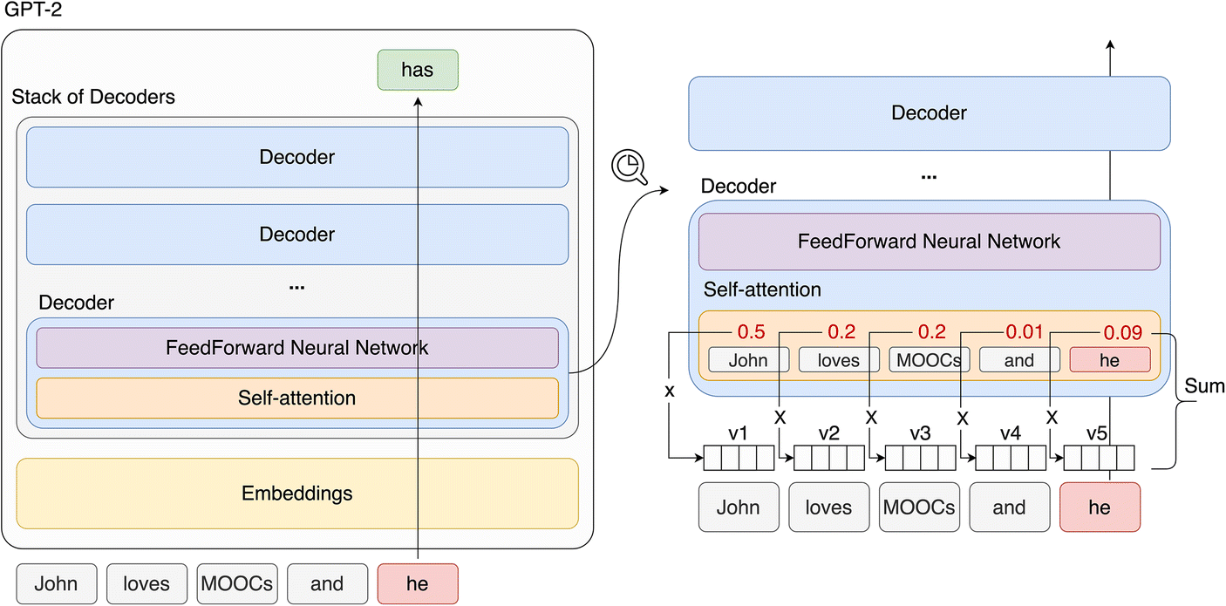

Architecture of ConvAI capable of automatically generating human-like and supportive texts

User interface of ConvAI browser extension to support math learning

User interface of ConvAI browser extension to support math learning.

**Relevant publications**

Check out the papers published in [British Journal of Educational Technology](https://bera-journals.onlinelibrary.wiley.com/doi/10.1111/bjet.13227), [Interactive Learning Environments](https://www.tandfonline.com/doi/abs/10.1080/10494820.2021.1993932), and [International Journal of Artificial Intelligence in Education](https://link.springer.com/article/10.1007/s40593-020-00235-x).